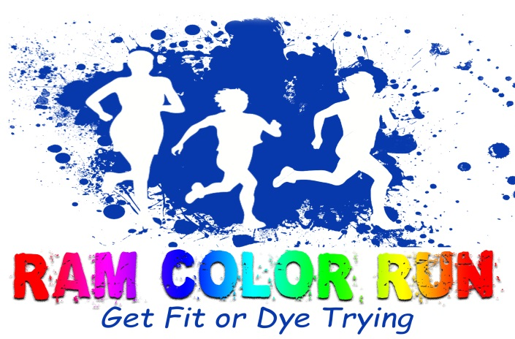

Random Lake Ram Color Run
Sponsorship Commitment

Company Name:__________________________________________________________

Contact Person:___________________________________________________________

Mailing Address:__________________________________________________________

E-mail Address:___________________________________________________________

Phone Number:___________________________________________________________

LOGO: If you would like your logo attached to our communications for this event, please email a png or jpg file of your company logo to friendsofrandomlakekids@outlook.com. Or, if you would rather, please provide a camera-ready black and white or color copy of your logo and submit it with this form.

______ Logo attached

Total 2016 sponsorship: $____________________

[ ] Enclosed is my check for $________________
(Make checks payable to Random Lake PTO)

[ ] We would like to provide volunteers to assist with race day activities.

[ ] Sorry, we are unable to support at this time. [ ] Please contact us again next year.

Send this form to: Name: Random Lake Middle School
Attention: Ann Averill
Address: 605 Random Lake Road, Random Lake, WI 53075
Email: aaverill@randomlake.k12.wi.us

